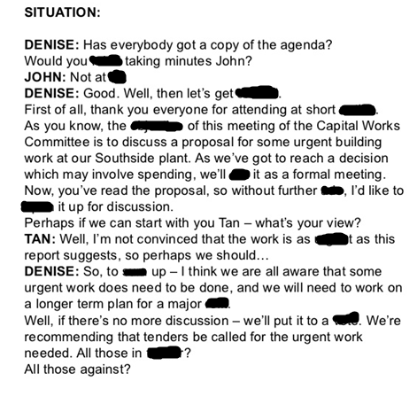

FavourX, mindX, allX, voteX , sum , run , put , objectiveX , notice , goingX , openX , urgentX , profit

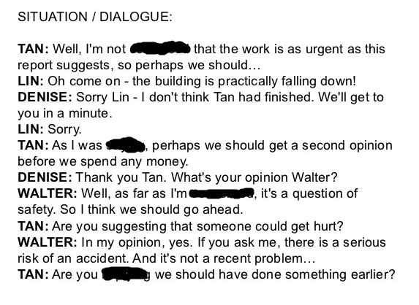

Saying , Convinced ,implying , concerned